Singleton problems:

1. Reflection issues, we can use reflection to create singleton instance.

2. With Serialization , we also can create a singleton instance.

3. Testing

Lazy initialization and Thread Safety ()

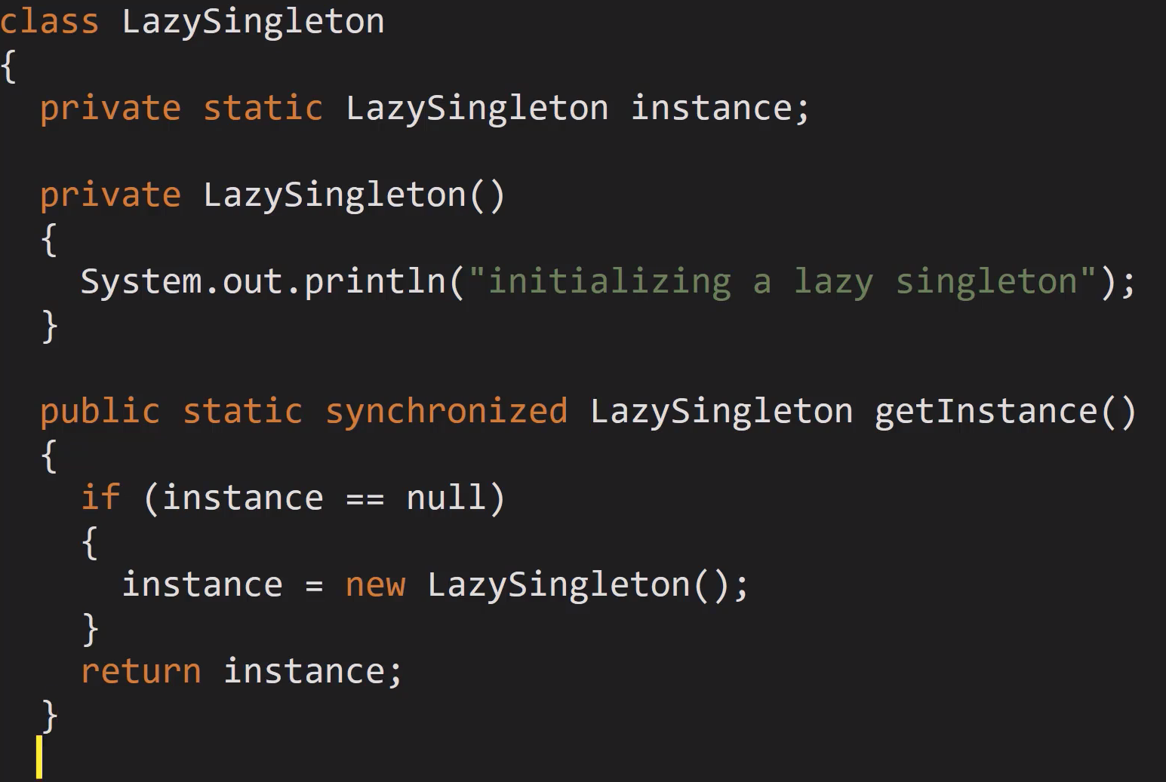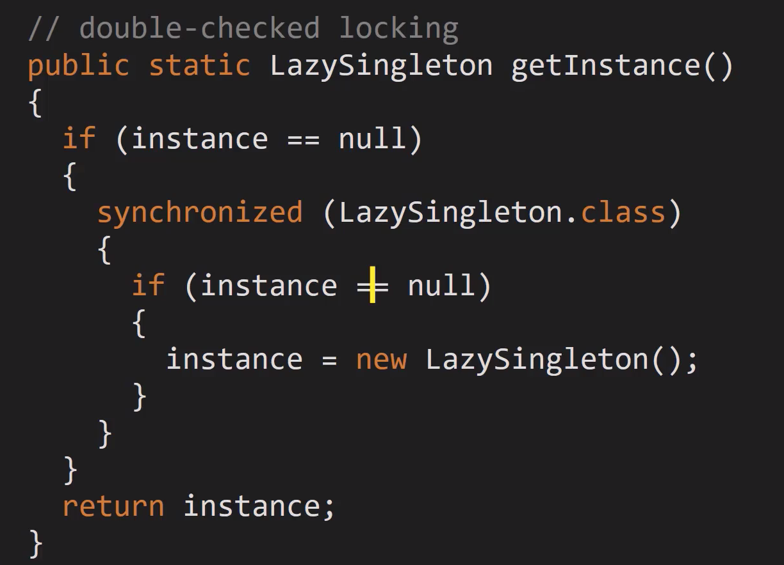

<https://www.antlr.org/index.html>